Motion and light intensity-based room lighting system

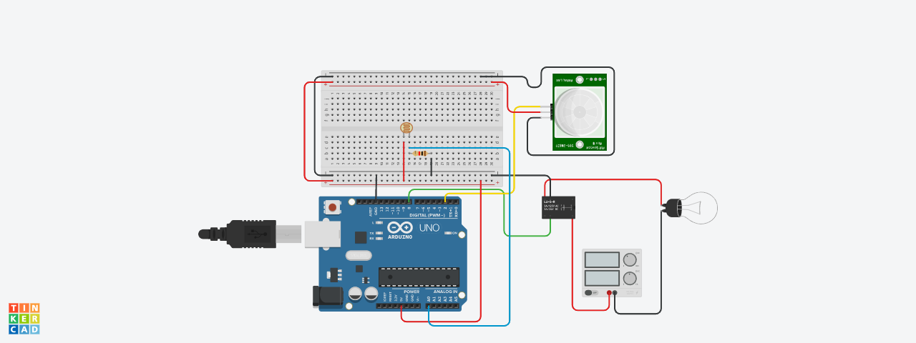

**C code for Motion and Light Intensity Based Room Lighting System**

int LightSensorVal = 0;

int PIRSensorVal = 0;

int RelayOutputVal = 0;

void setup()

{

pinMode(A0, INPUT);

pinMode(2, INPUT);

pinMode(8, OUTPUT);

Serial.begin(9600);

}

void loop()

{

LightSensorVal = analogRead(A0);

PIRSensorVal = digitalRead(2);

RelayOutputVal = 8;

if (LightSensorVal < 600) {

if (PIRSensorVal == HIGH) {

digitalWrite(8, HIGH);

delay(5000); // Wait for 5000 millisecond(s)

} else {

digitalWrite(8, LOW);

delay(1000); // Wait for 1000 millisecond(s)

}

} else {

digitalWrite(8, LOW);

Serial.println(LightSensorVal);

delay(300); // Wait for 300 millisecond(s)

}

}

**LINK FOR Motion and light intensity-based room lighting system Tinkercad**

https://www.tinkercad.com/things/0oxNmPMjBuA-copy-of-motion-and-light-intensity-based-room-lighting-system/editel?sharecode=LFVZGvgnHUoIaZszwKzrmuEICExgSh5GN-f4psddU9Y